Transport Demand Prediction System -Project Documentation

Team Details
Team Name: Code Slayers
- Manjula B – Frontend Developer (UI/UX, React, Visualization)
- Harini S – Backend Developer (API, Logic, Data Processing)
LinkedIn Profiles: Harini S
Manjula B
GitHub Repo: Transport-Demand-Prediction-System

Problem Understanding
The AasPass concept focuses on improving ride availability by connecting nearby passengers and drivers efficiently.

Gap Identified:
- Drivers don’t know where demand is high
- Passengers face long waiting times
- Demand fluctuates rapidly (noise vs real demand not identified)
- No smart prediction based on patterns (time, location, events)
So the problem is:
“How to intelligently identify real-time high-demand areas and waiting passengers while filtering noise?”

Solution Overview
We propose a Smart Demand Prediction System that combines:
- Time-based patterns (morning/evening rush)
- Day-based trends (weekday vs weekend)
- Real-time user activity
- Driver availability
- Waiting time analysis
- Cancellation behavior
- Event detection
- Zone-based clustering
👉 Output:
- Accurate Demand Score per Zone
- Driver alerts like:

“⚠️ High demand in your area – stay online”
- Heatmap visualization for easy understanding

Tech Stack
- Frontend: React.js
- Backend: Node.js + Express.js
- Database: MongoDB
- Architecture: MERN Stack

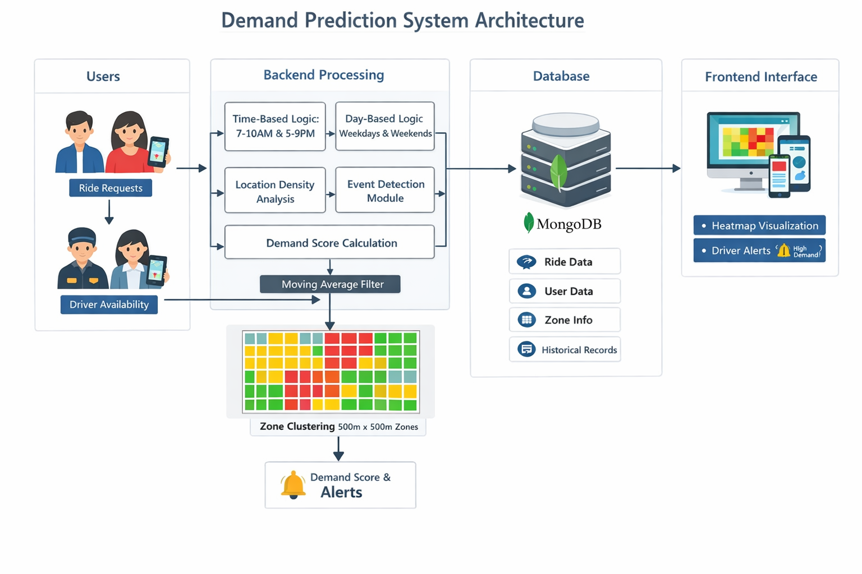

Core Logic Modules
1. Time-Based Demand
- Morning (7–10 AM): Office/College traffic
- Evening (5–9 PM): Return traffic
2. Day-Based Demand
- Weekdays → Work commute
- Weekends → Entertainment & shopping zones
3. Location Density Logic
- More app opens → higher demand signal
- Tracks user intent before booking
4. Noise Removal (Moving Average)
- Avoid false spikes
- Smooth demand using time-based averaging
5. Demand Score Formula
demand_score = number_of_requests / available_drivers
6. Waiting Time Analysis
- If waiting time > threshold → high demand
- Combined with request count for accuracy
7. Event Detection Logic
- Filters small groups (friends/family)
- Detects real events using:
  - User count (25+)
  - Continuous ride flow
  - Different drop locations
8. Zone Clustering
- City split into 500m × 500m zones
- Each zone tracks:
  - Requests
  - Drivers
  - Waiting time
  - Historical data
9. Heatmap Visualization
- 🔴 Red → High Demand
- 🟡 Yellow → Medium
- 🟢 Green → Low
10. Cancellation Pattern Analysis
- High cancellations + long wait → strong demand
- Ignore:
  - Instant cancellations (<5 sec)
  - Personal reasons

Execution Plan
Step-by-Step Implementation:
- Setup MERN Stack
  - Backend APIs (Node + Express)
  - MongoDB schema for rides, users, zones
- Data Collection
  - Ride requests
  - Driver availability
  - User activity
- Zone Creation
  - Divide city into 500m grids
- Core Logic Implementation
  - Demand score calculation
  - Moving average
  - Waiting time tracking
- Advanced Logic
  - Event detection
  - Cancellation filtering
- Frontend Development
  - Dashboard UI
  - Heatmap display
  - Driver alerts
- Testing
  - Simulate ride requests
  - Validate prediction accuracy
- Deployment
  - Push to GitHub
  - Host backend & frontend

Expected Impact
✔ Reduced passenger waiting time
✔ Better driver utilization
✔ Accurate real-time demand prediction
✔ Less ride cancellations
✔ Improved ride availability in busy areas

Overall Impact
This solution transforms the ride-booking system from a reactive model (waiting for requests) into a proactive, predictive system that anticipates demand before it peaks.
By intelligently balancing supply (drivers) and demand (passengers) in real time, it ensures:
- Faster ride allocation
- Reduced idle time for drivers
- Improved reliability of the platform
The integration of zone-based analysis, real-time signals, and behavioral patterns enables more precise and localized decision-making.
In the long run, this system can:
- Support scalable smart city transportation systems
- Improve urban mobility efficiency
- Enhance user trust and satisfaction
Overall, it delivers a data-driven, efficient, and intelligent mobility ecosystem that benefits both passengers and drivers while optimizing the entire ride-sharing network .

